# Nest a Subquery in FROM (Final Step)

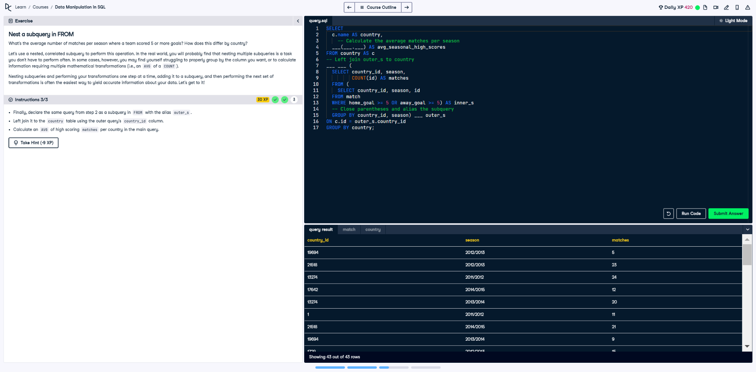

## Question

1. Finally, declare the same query from step 2 as a subquery in FROM with the alias outer_s.  
  
2. Left join it to the country table using the outer query's country_id column.  
  
3. Calculate an AVG of high-scoring matches per country in the main query.

## Corrected Solution

SELECT  
 c.name AS country,  
 -- Calculate the average matches per season  
 AVG(outer_s.matches) AS avg_seasonal_high_scores  
FROM country AS c  
-- Left join outer_s to country  
LEFT JOIN (  
 SELECT  
 country_id,  
 season,  
 COUNT(id) AS matches  
 FROM (  
 SELECT  
 country_id,  
 season,  
 id  
 FROM match  
 WHERE home_goal >= 5 OR away_goal >= 5  
 ) AS inner_s  
 -- Close parentheses and alias the subquery  
 GROUP BY country_id, season  
) AS outer_s  
ON c.id = outer_s.country_id  
GROUP BY country;

## Explanation

This query calculates the average number of high-scoring matches per season for each country. The innermost subquery filters matches where a team scored at least 5 goals and selects the relevant columns. The outer subquery groups these results by country and season, counting the matches. Finally, the main query joins these results with the country table and calculates the average matches per season for each country.